1.Write a python program to implement Simple Calculator program?
Aim:
To write a Python program to implement a simple calculator that performs addition, subtraction, multiplication, and division.
Algorithm:
- Start the program.
- Get two numbers from the user.
- Display the arithmetic operations: addition, subtraction, multiplication, and division.
- Get the user's choice of operation.
- Use if-elif-else statements to perform the selected operation.
- If division is selected, check whether the second number is zero.
- Display the result or an appropriate error message.
- Stop the program.
Program code:
a = float(input("Enter first number: "))
b = float(input("Enter second number: "))
print("1. Addition")
print("2. Subtraction")
print("3. Multiplication")
print("4. Division")
choice = int(input("Enter your choice: "))
if choice == 1:
print("Result =", a + b)
elif choice == 2:
print("Result =", a - b)
elif choice == 3:
print("Result =", a * b)
elif choice == 4:
if b != 0:
print("Result =", a / b)
else:
print("Division by zero is not possible")
else:
print("Invalid choice")

Output:
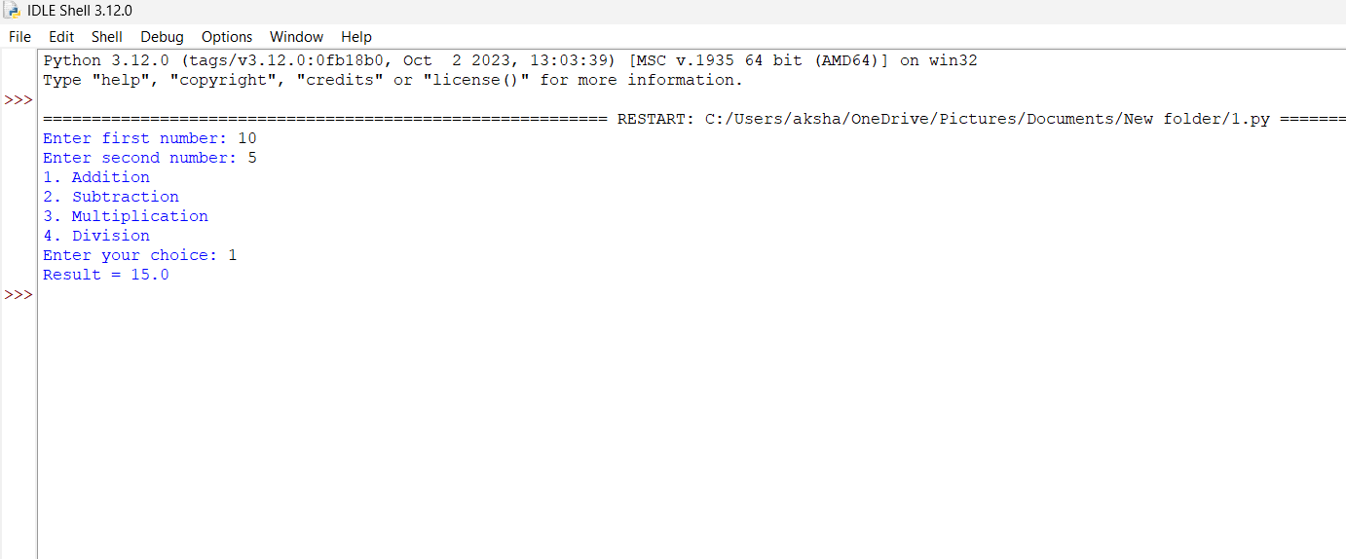

2. Write a python program to Add Two Matrices.
Aim
To write a Python program to add two matrices and display the resultant matrix.
Algorithm
- Start the program.
- Get the number of rows and columns from the user.
- Read the elements of the first matrix.
- Read the elements of the second matrix.
- Add the corresponding elements of both matrices.
- Store the sum in a resultant matrix.
- Display the resultant matrix.
- Stop the program.
Python Program:
r = int(input("Enter number of rows: "))
c = int(input("Enter number of columns: "))
print("Enter elements of first matrix:")
A = []
for i in range(r):
row = []
for j in range(c):
row.append(int(input()))
A.append(row)
print("Enter elements of second matrix:")
B = []
for i in range(r):
row = []
for j in range(c):
row.append(int(input()))
B.append(row)
C = []
for i in range(r):
row = []
for j in range(c):
row.append(A[i][j] + B[i][j])
C.append(row)
print("Sum of two matrices:")
for row in C:
print(row)
Output:
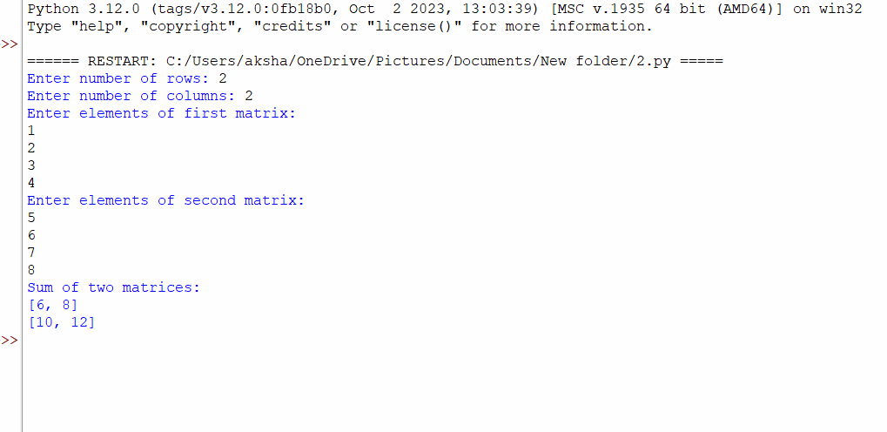
3. Write a python program to Transpose a Matrix.
Aim:To write a Python program to find the transpose of a matrix.
Algorithm:
- Start the program.
- Get the number of rows and columns from the user.
- Read the elements of the matrix.
- Interchange the rows and columns of the matrix.
- Display the transposed matrix.
- Stop the program.

Python Program:

r = int(input("Enter number of rows: "))

c = int(input("Enter number of columns: "))

A = []

print("Enter matrix elements:")

for i in range(r):

row = []

for j in range(c):

row.append(int(input()))

A.append(row)

print("Transpose of the matrix:")

for j in range(c):

for i in range(r):

print(A[i][j], end=" ")

print()

Output:

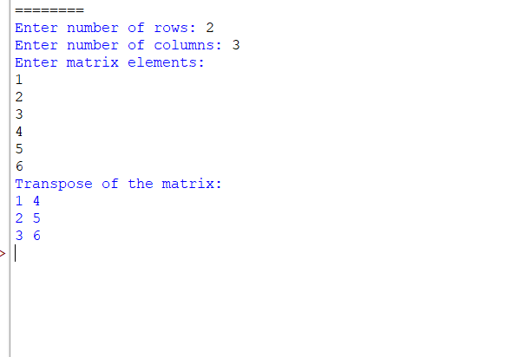

4. Write a python program to sort the sentence in alphabetical order?
Aim:
To write a Python program to sort the words in a sentence in alphabetical order.
Algorithm:
- Start the program.
- Get a sentence from the user.
- Split the sentence into individual words.
- Sort the words in alphabetical order using the sort() function.
- Display the sorted words.
- Stop the program.
Python Program:
sentence = input("Enter a sentence: ")
words = sentence.split()
words.sort()
print("Sentence in alphabetical order:")
print(" ".join(words))
Output:
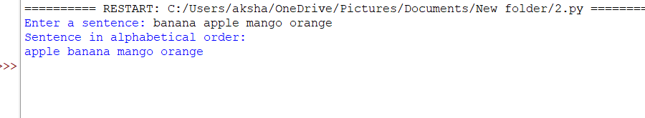
5. Write a python program to implement List operations (Nested List, Length,
Concatenation, Membership, Iteration, Indexing and Slicing)?
Aim:
To write a Python program to perform list operations such as nested list, length, concatenation, membership, iteration, indexing, and slicing.
Algorithm:
- Start the program.
- Create two lists.
- Create a nested list.
- Find the length of the list.
- Concatenate the two lists.
- Check whether an element is present in the list.
- Iterate through the list elements.
- Access an element using indexing.
- Extract elements using slicing.
- Display the results and stop the program.
Python Program:
a = [5, 10, 15, 20, 25]
b = [30, 35, 40]
# Nested List
print("Nested List:", [a, b])
# Length
print("Length:", len(a))
# Concatenation
print("Concatenated List:", a + b)
# Membership
print("Is 15 present?", 15 in a)
# Iteration
print("List Elements:")
for x in a:
print(x, end=" ")
print()
# Indexing
print("First Element:", a[0])
# Slicing
print("Sliced List:", a[1:4])
Output:
